AIRLINE RESERVATION SYSTEM

INDEX

1.INTRODUCTION……………………………………………………………………..1
1.1 Abstract……………………………………………………………………………1
1.2 Existing System……………………………………………………………………2
1.3 Proposed System…………………………………………………………………...2
2. REQUIREMENTS ……………………………………………………........................3
2.1 Hardware Requirements…………………………………………………………....4
2.2 Software Requirements…………………………………………………………….4
3. MODULE DESCRIPTION………………………………………………………….24
4. DESIGN………………………………………………………………………………27
4.1 Use case Diagram ………………………………………………………………..28
4.2 Class Diagram ……………………………………………………………………30
4.3 Sequence Diagram ……………………………………………………………….31
4.4 Collaboration Diagram……………………………………………………………32
4.5 E-R Diagram ……………………………………………………………………..33
4.6 Data dictionary……………………………………………………………………34
5. CODING……………………………………………………………………………...37
6. TESTING……………………………………………………………………………..58
7. OUTPUT SCREENS………………………………………………….......................63
8. CONCLUSION………………………………………………………………………78
9. BIBLIOGRAPHY …………………………………………………………………..80

INTRODUCTION

ABSTRACT

Airline Reservation System contains the details about flight schedules and its fare tariffs, passenger reservations and ticket records. An airline’s inventory contains all flights with their available seats. The inventory of an airline service is generally divided into three category of classes (e.g. First, Business or Economy class) and each category is having seats up to 26 bookings, along with prices and booking conditions. Inventory data is imported and maintained through a Schedule Distribution System over standardized interfaces. One of the core functions of the inventory management of airline reservations is the inventory control. Inventory control steers how many seats are available for the different booking classes, by opening and closing individual booking classes for sale. In combination with the fares and booking conditions stored in the Fare Quote System the price for each sold seat is determined.

1. INTRODUCTION

  - Existing System :
In few countries if a person wants to book a flight ticket, he use to follow one of these things:
- Manually goes to the Airport and book his ticket.
- Downloading the ticket form as paper document, filling it manually and submitting it at Airport.
- Fill the Ticket form on system and get the print out as paper documents to submit it at Airport.
- Booking the Ticket at some particular registered ticket counters in online.
- Even above approaches make a ticket booking online, it was not completely done on online. Passenger may not have much freedom over this approach.
- Hence the Passenger may or may not be satisfied with this approach as it includes manual intervention like travelling to Airport for booking his ticket.

1.2 Proposed System:

The Proposed system ensures the complete freedom for users, where user at his own system can logon to this website and can book his ticket. Our proposed system allows only registered users to book the tickets, view timings and cancel their tickets.
In this Proposal the entire work is done on online and ticket with id is also provided for passengers as a print document. Here passengers can send their queries and suggestions through a feedback form.

REQUIREMENTS

2. REQUIREMENTS

2.1 Hard ware Specification

- Processor : Intel Pentium3
- RAM : 512MB
- Hard disk : 2GB

  - Software Requirements

- Front end : .Net Framework 2.0
- Back end : SQL Server 2005
- Operating System : Windows 98/XP

Microsoft .NET Framework:
The .NET Framework is a new computing platform that simplifies application development in the highly distributed environment of the Internet.

Framework is designed to fulfill the following objectives:
- To provide a consistent object-oriented programming environment whether object code is stored and executed locally, executed locally but Internet-distributed, or executed remotely.
- To provide a code-execution environment that minimizes software deployment and versioning conflicts.
- To provide a code-execution environment that guarantees safe execution of code, including code created by an unknown or semi-trusted third party.
- To provide a code-execution environment that eliminates the performance problems of scripted or interpreted environments.
- To make the developer experience consistent across widely varying types of applications, such as Windows-based applications and Web-based applications.
- To build all communication on industry standards to ensure that code based on the .NET Framework can integrate with any other code.

The .NET Framework has two main components:
- The common language runtime.
- The .NET Framework class library.
The common language runtime is the foundation of the .NET Framework. You can think of the runtime as an agent that manages code at execution time, providing core services such as memory management, thread management, and remoting, while also enforcing strict type safety and other forms of code accuracy that ensure security and robustness. In fact, the concept of code management is a fundamental principle of the runtime. Code that targets the runtime is known as managed code, while code that does not target the runtime is known as unmanaged code. The class library, the other main component of the .NET Framework, is a comprehensive, object-oriented collection of reusable types that you can use to develop applications ranging from traditional command-line or graphical user interface (GUI) applications to applications based on the latest innovations provided by ASP.NET, such as Web Forms and XML Web services.

The .NET Framework can be hosted by unmanaged components that load the common language runtime into their processes and initiate the execution of managed code, thereby creating a software environment that can exploit both managed and unmanaged features. The .NET Framework not only provides several runtime hosts, but also supports the development of third-party runtime hosts.
For example, ASP.NET hosts the runtime to provide a scalable, server-side environment for managed code. ASP.NET works directly with the runtime to enable Web Forms applications and XML Web services, both of which are discussed later in this topic.

Internet Explorer is an example of an unmanaged application that hosts the runtime (in the form of a MIME type extension). Using Internet Explorer to host the runtime enables you to embed managed components or Windows Forms controls in HTML documents. Hosting the runtime in this way makes managed mobile code (similar to Microsoft® ActiveX® controls) possible, but with significant improvements that only managed code can offer, such as semi-trusted execution and secure isolated file storage.
The following illustration shows the relationship of the common language runtime and the class library to your applications and to the overall system. The illustration also shows how managed code operates within a larger architecture.

Features of the Common Language Runtime:
The common language runtime manages memory, thread execution, code execution, code safety verification, compilation, and other system services. These features are intrinsic to the managed code that runs on the common language runtime.

With regards to security, managed components are awarded varying degrees of trust, depending on a number of factors that include their origin (such as the Internet, enterprise network, or local computer). This means that a managed component might or might not be able to perform file-access operations, registry-access operations, or other sensitive functions, even if it is being used in the same active application.

The runtime enforces code access security. For example, users can trust that an executable embedded in a Web page can play an animation on screen or sing a song, but cannot access their personal data, file system, or network.

The security features of the runtime thus enable legitimate Internet-deployed software to be exceptionally feature rich.

The runtime also enforces code robustness by implementing a strict type- and code-verification infrastructure called the common type system (CTS). The CTS ensures that all managed code is self-describing. The various Microsoft and third-party language compilers

Generate managed code that conforms to the CTS. This means that managed code can consume other managed types and instances, while strictly enforcing type fidelity and type safety.

In addition, the managed environment of the runtime eliminates many common software issues. For example, the runtime automatically handles object layout and manages references to objects, releasing them when they are no longer being used. This automatic memory management resolves the two most common application errors, memory leaks and invalid memory references. The runtime also accelerates developer productivity.

For example, programmers can write applications in their development language of choice, yet take full advantage of the runtime, the class library, and components written in other languages by other developers. Any compiler vendor who chooses to target the runtime can do so. Language compilers that target the .NET Framework make the features of the .NET Framework available to existing code written in that language, greatly easing the migration process for existing applications.

While the runtime is designed for the software of the future, it also supports software of today and yesterday. Interoperability between managed and unmanaged code enables developers to continue to use necessary COM components and DLLs.

The runtime is designed to enhance performance. Although the common language runtime provides many standard runtime services, managed code is never interpreted. A feature called just-in-time (JIT) compiling enables all managed code to run in the native machine language of the system on which it is executing. Meanwhile, the memory manager removes the possibilities of fragmented memory and increases memory locality-of-reference to further increase performance.

Finally, the runtime can be hosted by high-performance, server-side applications, such as Microsoft® SQL Server™ and Internet Information Services (IIS). This infrastructure enables you to use managed code to write your business logic, while still enjoying the superior performance of the industry's best enterprise servers that support runtime hosting.

.NET Framework Class Library:
The .NET Framework class library is a collection of reusable types that tightly integrate with the common language runtime. The class library is object oriented, providing types from which your own managed code can derive functionality. This not only makes the .NET Framework types easy to use, but also reduces the time associated with learning new features of the .NET Framework. In addition, third-party components can integrate seamlessly with classes in the .NET Framework.

For example, the .NET Framework collection classes implement a set of interfaces that you can use to develop your own collection classes. Your collection classes will blend seamlessly with the classes in the .NET Framework.

As you would expect from an object-oriented class library, the .NET Framework types enable you to accomplish a range of common programming tasks, including tasks such as string management, data collection, database connectivity, and file access. In addition to these common tasks, the class library includes types that support a variety of specialized development scenarios. For example, we can use the .NET Framework to develop the following types of applications and services:

- Console applications.
- Scripted or hosted applications.
- Windows GUI applications (Windows Forms).
- ASP.NET applications.
- XML Web services.
- Windows services.
For example, the Windows Forms classes are a comprehensive set of reusable types that vastly simplify Windows GUI development. If you write an ASP.NET Web Form application, you can use the Web Forms classes.

Client Application Development:
Client applications are the closest to a traditional style of application in Windows-based programming. These are the types of applications that display windows or forms on the desktop, enabling a user to perform a task. Client applications include applications such as word processors and spreadsheets, as well as custom business applications such as data-entry tools, reporting tools, and so on. Client applications usually employ windows, menus, buttons, and other GUI elements, and they likely access local resources such as the file system and peripherals such as printers.

Another kind of client application is the traditional ActiveX control (now replaced by the managed Windows Forms control) deployed over the Internet as a Web page. This application is much like other client applications: it is executed natively, has access to local resources, and includes graphical elements.

In the past, developers created such applications using C/C++ in conjunction with the Microsoft Foundation Classes (MFC) or with a rapid application development (RAD) environment such as Microsoft® Visual Basic®.

The .NET Framework incorporates aspects of these existing products into a single, consistent development environment that drastically simplifies the development of client applications.

The Windows Forms classes contained in the .NET Framework are designed to be used for GUI development. You can easily create command windows, buttons, menus, toolbars, and other screen elements with the flexibility necessary to accommodate shifting business needs.
For example, the .NET Framework provides simple properties to adjust visual attributes associated with forms. In some cases the underlying operating system does not support changing these attributes directly, and in these cases the .NET Framework automatically recreates the forms. This is one of many ways in which the .NET Framework integrates the developer interface, making coding simpler and more consistent.

Unlike ActiveX controls, Windows Forms controls have semi-trusted access to a user's computer. This means that binary or natively executing code can access some of the resources on the user's system (such as GUI elements and limited file access) without being able to access or compromise other resources. Because of code access security, many applications that once needed to be installed on a user's system can now be safely deployed through the Web. Your applications can implement the features of a local application while being deployed like a Web page.

Introduction to C#.NET:
C# (pronounced as C-sharp) is a new language for windows applications, intended as an alternative to the main previous languages, C++, VB. Its purpose is two folds:
It gives access to many of the facilities previously available only in C++, while retaining some of the simplicity to learn of VB.
It has been designed specifically with the .NET Framework in mind, and hence is very well structured for writing code that will be compiled for the .NET.
C# is a simple, modern, object-oriented language which aims to combine the high productivity of VB and raw power of C++. C# is a new programming language developed by Microsoft.
Using C# we can develop console applications, web applications and windows applications .In C#, Microsoft has taken care of C++ problems such as memory management, pointers, so forth.

Active Server Pages .NET (ASP.NET)
ASP.NET is a programming framework built on the common language runtime that can be used on a server to build powerful Web applications. ASP.NET offers several important advantages over previous Web development models

Enhanced Performance: ASP.NET is compiled common language runtime code running on the server. Unlike its interpreted predecessors, ASP.NET can take advantage of early binding, just-in-time compilation, native optimization, and caching services right out of the box. This amounts to dramatically better performance before you ever write a line of code.

World-Class Tool Support: A rich toolbox and designer in the Visual Studio integrated development environment complement the ASP.NET framework. WYSIWYG editing, drag-and-drop server controls, and automatic deployment are just a few of the features this powerful tool provides.

Power and Flexibility: Because ASP.NET is based on the common language runtime, the power and flexibility of that entire platform is available to Web application developers. The .NET Framework class library, Messaging, and Data Access solutions are all seamlessly accessible from the Web. ASP.NET is also language-independent, so you can choose the language that best applies to your application or partition your application across many languages. Further, common language runtime interoperability guarantees that your existing investment in COM-based development is preserved when migrating to ASP.NET.

Simplicity: ASP.NET makes it easy to perform common tasks, from simple form submission and client authentication to deployment and site configuration. For example, the ASP.NET page framework allows you to build user interfaces that cleanly separate application logic from presentation code and to handle events in a simple, Visual Basic - like forms processing model.
Manageability: ASP.NET employs a text-based, hierarchical configuration system, which simplifies applying settings to your server environment and Web applications. Because configuration information is stored as plain text, new settings may be applied without the aid of local administration tools. This "zero local administration" philosophy extends to deploying ASP.NET Framework applications as well. An ASP.NET Framework application is deployed to a server simply by copying the necessary files to the server. No server restart is required, even to deploy or replace running compiled code.

Scalability and Availability: ASP.NET has been designed with scalability in mind, with features specifically tailored to improve performance in clustered and multiprocessor environments. Further, processes are closely monitored and managed by the ASP.NET runtime, so that if one misbehaves (leaks, deadlocks), a new process can be created in its place, which helps keep your application constantly available to handle requests.

Customizability and Extensibility: ASP.NET delivers a well-factored architecture that allows developers to "plug-in" their code at the appropriate level. In fact, it is possible to extend or replace any subcomponent of the ASP.NET runtime with your own custom-written component. Implementing custom authentication or state services has never been easier

Security: With built in Windows authentication and per-application configuration, you can be assured that your applications are secure.

Language Support
The Microsoft .NET Platform currently offers built-in support for many languages: C#, Visual Basic, Jscript etc.

What is ASP.NET Web Forms?
The ASP.NET Web Forms page framework is a scalable common language runtime-programming model that can be used on the server to dynamically generate Web pages.

Intended as a logical evolution of ASP (ASP.NET provides syntax compatibility with existing pages), the ASP.NET Web Forms framework has been specifically designed to address a number of key deficiencies in the previous model. In particular, it provides:
- The ability for developers to cleanly structure their page logic in an orderly fashion (not "spaghetti code").
- The ability for development tools to provide strong WYSIWYG design support for pages (existing ASP code is opaque to tools).
- The ability to create and use reusable UI controls that can encapsulate common functionality and thus reduce the amount of code that a page developer has to write.

ASP.NET Web Forms pages are text files with an. aspx file name extension. They can be deployed throughout an IIS virtual root directory tree. When a browser client requests. Aspx resources, the ASP.NET runtime parses and compiles the target file into a .NET Framework class. This class can then be used to dynamically process incoming requests. (Note that the .aspx file is compiled only the first time it is accessed; the compiled type instance is then reused across multiple requests).

An ASP.NET page can be created simply by taking an existing HTML file and changing its file name extension to .aspx (no modification of code is required). For example, the following sample demonstrates a simple HTML page that collects a user's name and category preference and then performs a form post back to the originating page when a button is clicked:
ASP.NET provides syntax compatibility with existing ASP pages. This includes support for <% %> code render blocks that can be intermixed with HTML content within an .aspx file. These code blocks execute in a top-down manner at page render time.

Code-Behind Web Forms :
ASP.NET supports two methods of authoring dynamic pages. The first is the method shown in the preceding samples, where the page code is physically declared within the originating .aspx file. An alternative approach is known as the code-behind method where the page code can b e more cleanly separated from the HTML content into an entirely separate file.

Introduction to ASP.NET Server Controls

In addition to (or instead of) using <% %> code blocks to program dynamic content, ASP.NET page developers can use ASP.NET server controls to program Web Pages. Server controls are declared within an .aspx file using custom tags or intrinsic HTML tags that contains a run at="server" attributes value. Intrinsic HTML tags are handled by one of the controls in the System.Web.UI.HtmlControls namespace. Any tag that doesn't explicitly map to one of the controls is assigned the type of:
System.Web.UI.Html Controls.HtmlGenericControl.

Server controls automatically maintain any client-entered values between round trips to the server. This control state is not stored on the server (it is instead stored within an <input type="hidden"> form field that is round-tripped between requests). Note also that no client-side script is required.

In addition to supporting standard HTML input controls, ASP.NET enables developers to utilize richer custom controls on their pages. For example, the following sample demonstrates how the <asp: adrotator> control can be used to dynamically display rotating ads on a page.
- ASP.NET Web Forms provide an easy and powerful way to build dynamic Web UI.
- ASP.NET Web Forms pages can target any browser client (there are no script library or cookie requirements).
- ASP.NET Web Forms pages provide syntax compatibility with existing ASP pages.
- ASP.NET server controls provide an easy way to encapsulate common functionality.
- ASP.NET ships with 45 built-in server controls. Developers can also use controls built by third parties.
- ASP.NET server controls can automatically project both up level and down-level HTML.

ADO.NET Overview:
ADO.NET is an evolution of the ADO data access model that directly addresses user requirements for developing scalable applications. It was designed specifically for the web with scalability, statelessness, and XML in mind.

ADO.NET uses some ADO objects, such as the Connection and Command objects, and also introduces new objects. Key new ADO.NET objects include the Data Set, Data Reader, and Data Adapter.

The important distinction between this evolved stage of ADO.NET and previous data architectures is that there exists an object -- the DataSet -- that is separate and distinct from any data stores. Because of that, the DataSet functions as a standalone entity. You can think of the DataSet as an always disconnected record set that knows nothing about the source or destination of the data it contains. Inside a DataSet, much like in a database, there are tables, columns, relationships, constraints, views, and so forth.

A DataAdapter is the object that connects to the database to fill the DataSet. Then, it connects back to the database to update the data there, based on operations performed while the DataSet held the data.

In the past, data processing has been primarily connection-based. Now, in an effort to make multi-tiered apps more efficient, data processing is turning to a message-based approach that revolves around chunks of information. At the center of this approach is the DataAdapter, which provides a bridge to retrieve and save data between a DataSet and its source data store.

It accomplishes this by means of requests to the appropriate SQL commands made against the data store.

The XML-based DataSet object provides a consistent programming model that works with all models of data storage: flat, relational, and hierarchical. It does this by having no 'knowledge' of the source of its data, and by representing the data that it holds as collections and data types. No matter what the source of the data within the DataSet is, it is manipulated through the same set of standard APIs exposed through the DataSet and its subordinate objects.

While the DataSet has no knowledge of the source of its data, the managed provider has detailed and specific information. The role of the managed provider is to connect, fill, and persist the DataSet to and from data stores. The OLE DB and SQL Server .NET Data Providers (System.Data.OleDb and System.Data.SqlClient) that are part of the .Net Framework provide four basic objects: the Command, Connection, Data Reader and DataAdapter. In the remaining sections of this document, we'll walk through each part of the DataSet and the OLE DB/SQL Server .NET Data Providers explaining what they are, and how to program against them. The following sections will introduce you to some objects that have evolved, and some that are new. These objects are:

- Connections. For connection to and managing transactions against database.
- Commands. For issuing SQL commands against a database.
- Data Readers. For reading a forward-only stream of data records from a SQL Server data source.
- Datasets. For storing, remoting and programming against flat data, XML data and relational data.
- Data Adapters. For pushing data into a DataSet, and reconciling data against a database.
- Connections

Connections are used to 'talk to' databases, and are represented by provider-specific classes such as SQLConnection. Commands travel over connections and result sets are returned in the form of streams which can be read by a Data Reader object, or pushed into a DataSet object.
Commands :
Commands contain the information that is submitted to a database, and are represented by provider-specific classes such as SQLCommand. A command can be a stored procedure call, an UPDATE statement, or a statement that returns results. You can also use input and output parameters, and return values as part of your command syntax. The example below shows how to issue an INSERT statement against the Northwind database.

Data Readers :
The Data Reader object is somewhat synonymous with a read-only/forward-only cursor over data. The Data Reader API supports flat as well as hierarchical data. A Data Reader object is returned after executing a command against a database.The format of the returned DataReader object is different from a recordset. For example, you might use the DataReader to show the results of a search list in a web page.

Data Sets and Data Adapters:

Data Sets:
The DataSet object is similar to the ADO Record set object, but more powerful, and with one other important distinction: the DataSet is always disconnected. The DataSet object represents a cache of data, with database-like structures such as tables, columns, relationships, and constraints.

However, though a DataSet can and does behave much like a database, it is important to remember that DataSet objects do not interact directly with databases, or other source data. This allows the developer to work with a programming model that is always consistent, regardless of where the source data resides.

Data coming from a database, an XML file, from code, or user input can all be placed into DataSet objects. Then, as changes are made to the DataSet they can be tracked and verified before updating the source data. The GetChanges method of the DataSet object actually creates a second DatSet that contains only the changes to the data. This DataSet is then used by a DataAdapter (or other objects) to update the original data source.
The DataSet has many XML characteristics, including the ability to produce and consume XML data and XML schemas. XML schemas can be used to describe schemas interchanged via Web Services. In fact, a DataSet with a schema can actually be compiled for type safety and statement completion.

Data Adapters (OLEDB/SQL)
The DataAdapter object works as a bridge between the DataSet and the source data. Using the provider-specific SqlDataAdapter (along with its associated Sqlcommand and SqlConnection) can increase overall performance when working with a Microsoft SQL Server databases. For other OLE DB-supported databases, you would use the OleDbDataAdapter object and its associated OleDbCommand and OleDbConnection objects.
The DataAdapter object uses commands to update the data source after changes have been made to the DataSet. Using the Fill method of the DataAdapter calls the SELECT command; using the Update method calls the INSERT, UPDATE or DELETE command for each changed row. You can explicitly set these commands in order to control the statements used at runtime to resolve changes, including the use of stored procedures. For ad-hoc scenarios, a Command Builder object can generate these at run-time based upon a select statement.

SQL SERVER

DATABASE:

A database management, or DBMS, gives the user access to their data and helps them transform the data into information. Such database management systems include dBase, paradox, IMS, SQL Server and SQL Server. These systems allow users to create, update and extract information from their database.

A database is a structured collection of data. Data refers to the characteristics of people, things and events. SQL Server stores each data item in its own fields. In SQL Server, the fields relating to a particular person, thing or event are bundled together to form a single complete unit of data, called a record (it can also be referred to as raw or an occurrence). Each record is made up of a number of fields. No two fields in a record can have the same field name.

During an SQL Server Database design project, the analysis of your business change over time, you define any additional fields or change the definition of existing fields.

SQL Server Tables
SQL Server stores records relating to each other in a table. Different tables are created for the various groups of information. Related tables are grouped together to form a database.

Primary Key
Every table in SQL Server has a field or a combination of fields that uniquely identifies each record in the table. The Unique identifier is called the Primary Key, or simply the Key. The primary key provides the means to distinguish one record from all other in a table. It allows the user and the database system to identify, locate and refer to one particular record in the database.

Foreign Key
When a field is one table matches the primary key of another field is referred to as a foreign key. A foreign key is a field or a group of fields in one table whose values match those of the primary key of another table.needs identifies all the fields or attributes of interest. If your business needs

MODULE DESCRIPTION

3. MODULE DESCRIPTION

The list of modules incorporated with “AIRLINE RESERVATION SYSTEM” are

- Registration module

- Administrative module

- Passenger module

1. Registration module

In registration module first we ask passenger to give his details.After registering with us the passenger can logon to his/her own account and can view all flight details such as Timings, Prices,Availability of seats and can book the ticket with unique ticket id.Once Passenger registered with us can book any number of tickets.

2. Administrative module

Administrative module is provided for the sake of administrators to manage the site and update the content at regular intervals, The major operations included in this module are:

- Create and maintain airline schedule, fare and timings of the Flight.
- View the passenger list.
- View the available seats in the flights.
- Cancel the tickets.
- Updating the flight schedule and timings and fare.

3. Passenger module

This module is meant for passengers, where a user logging into his/her owns account will view this panel. The major operations included in this module were

- View all airline schedules, timings, fare details and seats availability.
- Book for the tickets.
- View and cancelling of the ticket.
- Send feedback.

Behind these modules, it also includes additional WebPages like Password recovery console, Tips regarding journey, Traveling news around world and help regarding our site.

DESIGN

4. DESIGN
UML DIAGRAMS:

4.1 Use case diagram

Login
Scheduling flights
View passenger list
Cancel the ticket
view feedback
Log out
ADMIN

View flight timings
and availability
Book the ticket
Send feedback
Send cancel request
Log out
Register
Login
USER

- Class Diagram 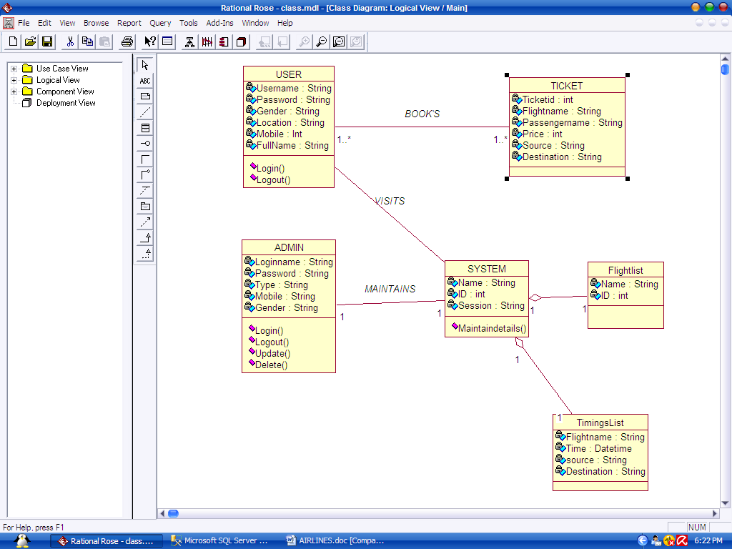

4.3 Sequence diagram
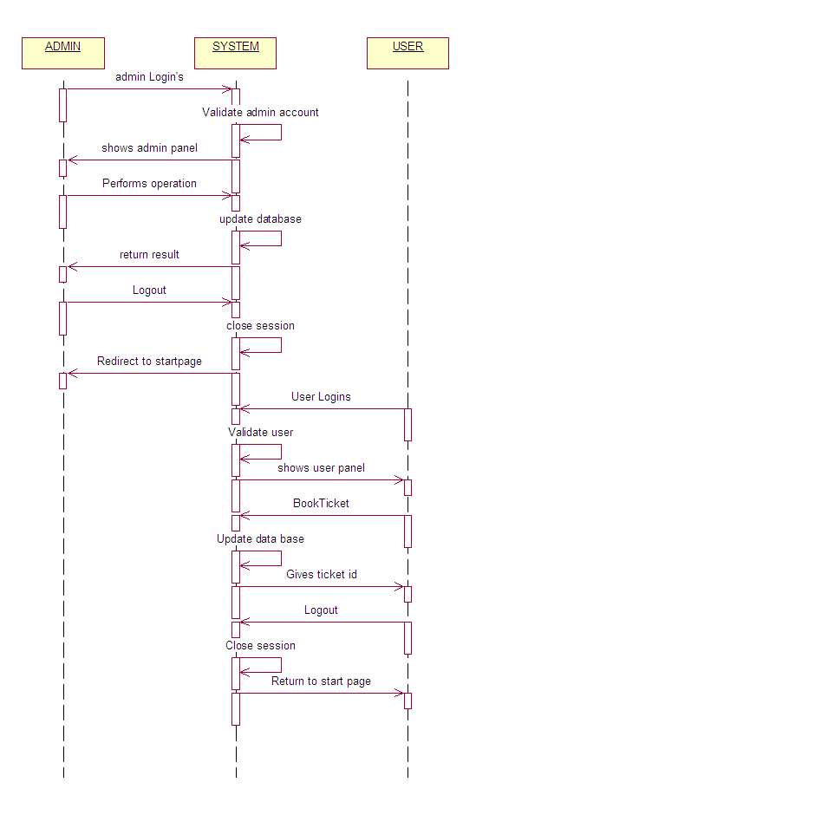

4.4 Collaboration diagram
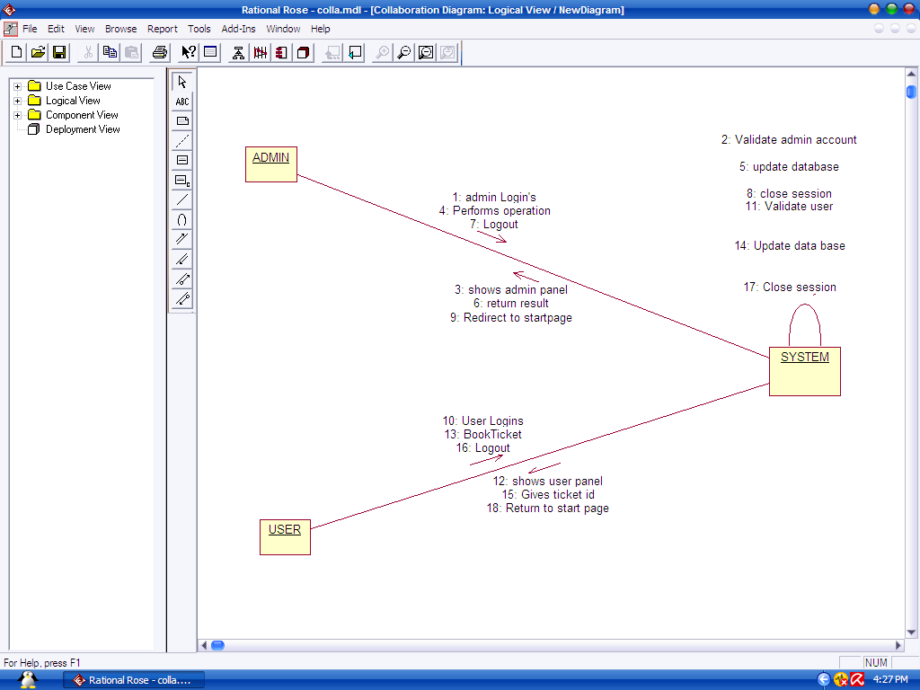

4.5 E-R diagram
TICKET BOOKING
Ticket id no
Passengername
DestinationStationon
No.passengers
SourceStation
FligthName
LOGIN
Loginnamee
Password
Name
Gender
Mobile
Location
Type
SCHEDULING
Flightname
Time
Sourcestation
ID
Destination Station
FEEDBACK
Name
Email
Subject
Seats
Books
Depends
Gives

4.5 Data dictionary
FEEDBACK TABLE

ATTRIBUTE NAME | DATATYPE | CONSTRAINTS | SAMPLE VALUES
ID | Int | Primary key | 1
Name | Varchar(50) | Not null | suhas
Email | Varchar(50) | Not null | suhasravva@yahoo.com
Subject | Varchar(50) | Not null | Password
Message | Varchar(MAX) | Null | Some text message here

SCHEDULING TABLE

ATTRIBUTE NAME | DATATYPE | CONSTRAINTS | SAMPLE VALUE
Flightname | Varchar(50) | Primary key | Suhas
Time | Datetime | Not null | 27/06/2010 6:55:00 AM
Sourcestation | Varchar(50) | Not null | HYD
Destinationstation | Varchar(50) | Not null | NEW DELHI
Seats | int | Not null | 120
Price | int | Not null | 1200

TICKETBOOKING TABLE

ATTRIBUTE NAME | DATATYPE | CONSTRAINTS | SAMPLE VALUES
Passengername | Varchar(50) | Foreign key | Suhas
Flightname | Varchar(50) | Foreign key | Kingfisher
Sourcestation | Varchar(50) | Not null | HYD
Destinationstation | Varchar(50) | Not null | DELHI
Ticketno | int | Primary key | 104
Numberof paasengers | Int | Not null | 3

REGISTRATION TABLE

ATTRIBUTE NAME | DATATYPE | CONSTRAINTS | SAMPLEVALUES
Username | Varchar2(20) | Primary key | Suhas
Password | Varchar2(20) | check | Suhas1230
First name | Number(10) | Not null | Suhas Ravva
Gender | Varchar2(20) | Not null | Male
Location | Number (20) | Not null | INDIA
Phno | Number(10) | Not null | 9177761547

CODING

5. CODING

Register.aspx

using System;
using System.Data;
using System.Configuration;
using System.Collections;
using System.Web;
using System.Web.Security;
using System.Web.UI;
using System.Web.UI.WebControls;
using System.Web.UI.WebControls.WebParts;
using System.Web.UI.HtmlControls;
using System.Data.SqlClient;
public partial class Default2 : System.Web.UI.Page
{
int k= 0,l=0;
protected void Page_Load(object sender, EventArgs e)
{

}
protected void TextBox1_TextChanged(object sender, EventArgs e)
{

}
protected void TextBox3_TextChanged(object sender, EventArgs e)
{
if (TextBox5.Text != TextBox3.Text)
{
Label11.Visible = true;
Label11.Text = "password mismatched";
k = k + 1;
}
}
protected void TextBox4_TextChanged(object sender, EventArgs e)
{

}
protected void Button2_Click(object sender, EventArgs e)
{

}
protected void RadioButton1_CheckedChanged(object sender, EventArgs e)
{

}
protected void RadioButtonList1_SelectedIndexChanged(object sender, EventArgs e)
{

}
protected void CheckBox1_CheckedChanged(object sender, EventArgs e)
{

l = l + 1;
}
String constring = ConfigurationManager.ConnectionStrings["con"].ConnectionString.ToString();
protected void Button1_Click(object sender, EventArgs e)
{
SqlConnection con = new SqlConnection(constring);
SqlCommand cmd = new SqlCommand();
cmd.CommandType = CommandType.Text;
cmd.Connection = con;
con.Open();
Label9.Text = "user";
cmd.CommandText = "select Loginname from Login";
SqlDataAdapter da = new SqlDataAdapter();
da.SelectCommand = cmd;
DataSet ds = new DataSet();
da.Fill(ds, "emp");
int c = 0;
for (int i = 0; i < ds.Tables["emp"].Rows.Count; i++)
{
if (ds.Tables["emp"].Rows[i]["Loginname"].ToString() == TextBox2.Text)
{
c = c + 1;

}
}
if (k == 0 && l>0)
{
l = 0;

if (c == 0)
{

if (TextBox1.Text != "" && TextBox2.Text != "" && TextBox4.Text!="" && TextBox3.Text != "")
{

cmd.CommandText = "insert into Login(Loginname,Password,Name,Gender,Location,Phno,Type) values('" + TextBox2.Text + "','" + TextBox3.Text + "','" + TextBox1.Text + "','" + RadioButtonList1.Text + "','" + DropDownList1.Text + "','" + TextBox4.Text + "','" + Label9.Text + "')";

int i = cmd.ExecuteNonQuery();
if (i == 1)
{

Label8.Visible = false;
Label12.Visible = true;
Label12.Text = "successfully registered,click on login..your login name is: " + TextBox2.Text;

}
else
{
Label8.Visible = true;
Label8.Text = "some thing went wrong try again";
}
}
else
{
Label8.Visible = true;
Label8.Text = "some fields are left empty";
}
}
else
{
Label8.Visible = true;
Label8.Text = "Login name already exists";
}
}
else
{
Label8.Visible = true;
Label8.Text = "you need to accept our terms and conditions";
}

}

protected void TextBox2_TextChanged1(object sender, EventArgs e)
{

}
protected void TextBox5_TextChanged(object sender, EventArgs e)
{

}

}

Login.aspx

using System;
using System.Data;
using System.Configuration;
using System.Collections;
using System.Web;
using System.Web.Security;
using System.Web.UI;
using System.Web.UI.WebControls;
using System.Web.UI.WebControls.WebParts;
using System.Web.UI.HtmlControls;
using System.Data.SqlClient;
public partial class login : System.Web.UI.Page
{
protected void Page_Load(object sender, EventArgs e)
{

}
protected void Button1_Click(object sender, EventArgs e)
{

}
protected void Button2_Click(object sender, EventArgs e)
{

}
protected void TextBox2_TextChanged(object sender, EventArgs e)
{

}
protected void TextBox1_TextChanged(object sender, EventArgs e)
{

}
String constring = ConfigurationManager.ConnectionStrings["con"].ConnectionString.ToString();
protected void Button2_Click1(object sender, EventArgs e)
{
SqlConnection con = new SqlConnection(constring);
SqlCommand cmd = new SqlCommand();
cmd.CommandType = CommandType.Text;
cmd.Connection = con;
con.Open();
cmd.CommandText = "select Loginname,Type from Login where Loginname='" + TextBox1.Text + "'and Password='" + TextBox2.Text + "'and Type='"+DropDownList1.Text+"'";
SqlDataAdapter da = new SqlDataAdapter();
da.SelectCommand = cmd;
DataSet ds = new DataSet();
da.Fill(ds, "emp");
if (ds.Tables["emp"].Rows.Count > 0)
{
Session["Type"] = ds.Tables["emp"].Rows[0]["Type"].ToString();
Session["Loginname"] = ds.Tables["emp"].Rows[0]["Loginname"].ToString();
Response.Redirect("Home.aspx");
}
else
{
Label4.Visible = true;
Label4.Text = "invalid username or password";
}
con.Close();
}

Masterpage.aspx

using System;
using System.Data;
using System.Configuration;
using System.Collections;
using System.Web;
using System.Web.Security;
using System.Web.UI;
using System.Web.UI.WebControls;
using System.Web.UI.WebControls.WebParts;
using System.Web.UI.HtmlControls;
using System.Data.SqlClient;
public partial class MasterPage : System.Web.UI.MasterPage
{
protected void Page_Load(object sender, EventArgs e)
{
if (Session["Type"] != null)
{
if (Session["Type"].ToString() == "admin")
{

pnlcust.Visible = false;
pnlog.Visible = true;
pnladmin.Visible = true;

}
else
{
pnlcust.Visible = true;
pnlog.Visible = true;
pnladmin.Visible = false;
}
}
else
{
pnlcust.Visible = false;
pnlog.Visible = true;
pnladmin.Visible = false;
}

}
protected void Menu2_MenuItemClick(object sender, MenuEventArgs e)
{

}
protected void LinkButton2_Click(object sender, EventArgs e)
{

Session["Type"] = null;
Response.Redirect("login.aspx");

}
protected void Menu1_MenuItemClick(object sender, MenuEventArgs e)
{

}
protected void Menu3_MenuItemClick(object sender, MenuEventArgs e)
{

}
protected void Linkbutton1_Click(object sender, EventArgs e)
{
Session.RemoveAll();
Response.Redirect("Home.aspx");
}
}

Ticketbooking.aspx

using System;
using System.Data;
using System.Configuration;
using System.Collections;
using System.Web;
using System.Web.Security;
using System.Web.UI;
using System.Web.UI.WebControls;
using System.Web.UI.WebControls.WebParts;
using System.Web.UI.HtmlControls;
using System.Data.SqlClient;
public partial class Default2 : System.Web.UI.Page
{
protected void Page_Load(object sender, EventArgs e)
{

}
String constring = ConfigurationManager.ConnectionStrings["con"].ConnectionString.ToString();
protected void Button1_Click1(object sender, EventArgs e)
{
SqlConnection con = new SqlConnection(constring);
SqlCommand cmd = new SqlCommand();
cmd.CommandType = CommandType.Text;
cmd.Connection = con;
con.Open();

cmd.CommandText = "insert into Ticketbooking(Passengername,Flightname,Sourcestation,Destinationstation,Numberofpassengers) values('" + Session["Loginname"] + "','" + DropDownList1.Text + "','" + DropDownList2.Text + "','" + DropDownList3.Text + "','"+DropDownList4.Text+"')";
SqlDataAdapter da = new SqlDataAdapter();
da.InsertCommand = cmd;
int i = cmd.ExecuteNonQuery();
cmd.CommandText = "update Scheduling set Seats=Seats-'"+DropDownList4.Text+"' where FlightName='" + DropDownList1.Text + "'";
int j = cmd.ExecuteNonQuery();
if (i == 1 && j == 1)
{
Label5.Visible = true;
Label5.Text = "successfully booked your ticket,click on generate to know ticket number";

}
else
{
Label5.Visible = true;
Label5.Text = "Server buzy try again";
}

con.Close();
}

protected void Button2_Click(object sender, EventArgs e)
{
SqlConnection con = new SqlConnection(constring);
SqlCommand cmd = new SqlCommand();
cmd.CommandType = CommandType.Text;
cmd.Connection = con;
con.Open();
cmd.CommandText = "select Ticketno from Ticketbooking where PassengerName='" + Session["Loginname"] + "'";
SqlDataAdapter da = new SqlDataAdapter();
da.SelectCommand = cmd;
DataSet ds = new DataSet();
da.Fill(ds, "emp");
if (ds.Tables["emp"].Rows.Count!=0 )
{
int k = ds.Tables["emp"].Rows.Count;
Label5.Visible = true;
Label5.Text = "YOUR TICKET NUMBER IS : "+ds.Tables["emp"].Rows[k-1]["Ticketno"].ToString();

}
else
{
Label5.Visible = true;
Label5.Text = "Try again to book for ticket";
}
con.Close();
}
}

Cancelticket.aspx

using System;
using System.Data;
using System.Configuration;
using System.Collections;
using System.Web;
using System.Web.Security;
using System.Web.UI;
using System.Web.UI.WebControls;
using System.Web.UI.WebControls.WebParts;
using System.Web.UI.HtmlControls;
using System.Data.SqlClient;
public partial class Default2 : System.Web.UI.Page
{

String constring = ConfigurationManager.ConnectionStrings["con"].ConnectionString.ToString();
protected void Button1_Click(object sender, EventArgs e)
{
SqlConnection con = new SqlConnection(constring);
SqlCommand cmd = new SqlCommand();
cmd.CommandType = CommandType.Text;
cmd.Connection = con;
con.Open();

cmd.CommandText = "select Numberofpassengers from Ticketbooking where Ticketno='" + TextBox2.Text + "'";
SqlDataAdapter da = new SqlDataAdapter();
da.SelectCommand = cmd;
DataSet ds = new DataSet();
da.Fill(ds, "emp");
int a = Convert.ToInt16(ds.Tables["emp"].Rows[0]["Numberofpassengers"]);

cmd.CommandText = "delete from Ticketbooking where Passengername='" + Session["Loginname"] + "'and Flightname='" + DropDownList1.Text + "' and Ticketno='" + TextBox2.Text + "'";
int i = cmd.ExecuteNonQuery();
da.DeleteCommand = cmd;

if (i == 1)
{
cmd.CommandText = "update scheduling set Seats=Seats+'"+a+"' where Flightname='" + DropDownList1.Text + "'";
int j = cmd.ExecuteNonQuery();
if (j == 1)
{
Label4.Visible = true;
Label4.Text = "successfully canceled ";
}
else
{
Label4.Visible = true;
Label4.Text = "database not updated";
}
}
else
{
Label4.Visible = true;
Label4.Text = "Server buzy try again";
}

con.Close();
}
}

Addnewflight.aspx

using System;
using System.Data;
using System.Configuration;
using System.Collections;
using System.Web;
using System.Web.Security;
using System.Web.UI;
using System.Web.UI.WebControls;
using System.Web.UI.WebControls.WebParts;
using System.Web.UI.HtmlControls;
using System.Data.SqlClient;
public partial class Default3 : System.Web.UI.Page
{

string constring = ConfigurationManager.ConnectionStrings["con"].ConnectionString.ToString();
protected void Button1_Click(object sender, EventArgs e)
{
SqlConnection con = new SqlConnection(constring);
SqlCommand cmd = new SqlCommand();
cmd.CommandType = CommandType.Text;
cmd.Connection = con;
con.Open();
cmd.CommandText = "insert into Scheduling(Flightname,Time,Sourcestation,Destinationstation,Seats,Price) values('" + TextBox1.Text + "','" + TextBox2.Text + "','" + TextBox3.Text + "','" + TextBox4.Text + "','" + TextBox5.Text + "','" + TextBox6.Text + "')";
SqlDataAdapter da = new SqlDataAdapter();
da.InsertCommand = cmd;
int i = cmd.ExecuteNonQuery();
if (i == 1)
{

TextBox2.Text = "";
TextBox3.Text = "";
TextBox1.Text = "";
TextBox4.Text = "";
TextBox5.Text = "";
TextBox6.Text = "";

Label7.Visible = true;
Label7.Text = "successfully added";

}
else
{
Label7.Visible = true;
Label7.Text = "not added";
}
con.Close();
}
}

Timings.aspx

using System;
using System.Data;
using System.Configuration;
using System.Collections;
using System.Web;
using System.Web.Security;
using System.Web.UI;
using System.Web.UI.WebControls;
using System.Web.UI.WebControls.WebParts;
using System.Web.UI.HtmlControls;

public partial class Default3 : System.Web.UI.Page
{
protected void Page_Load(object sender, EventArgs e)
{

}
protected void Button1_Click(object sender, EventArgs e)
{
GridView1.Visible = true;
}
protected void Button1_Click1(object sender, EventArgs e)
{

}
}

Scheduling.aspx

using System;
using System.Data;
using System.Configuration;
using System.Collections;
using System.Web;
using System.Web.Security;
using System.Web.UI;
using System.Web.UI.WebControls;
using System.Web.UI.WebControls.WebParts;
using System.Web.UI.HtmlControls;

public partial class Default2 : System.Web.UI.Page
{
protected void Page_Load(object sender, EventArgs e)
{

}
protected void GridView1_SelectedIndexChanged(object sender, EventArgs e)
{

}
protected void Button1_Click(object sender, EventArgs e)
{
Response.Redirect("AddnewFlight.aspx");
}
}

Passengerlist.aspx

using System;
using System.Data;
using System.Configuration;
using System.Collections;
using System.Web;
using System.Web.Security;
using System.Web.UI;
using System.Web.UI.WebControls;
using System.Web.UI.WebControls.WebParts;
using System.Web.UI.HtmlControls;

public partial class Default3 : System.Web.UI.Page
{
protected void Page_Load(object sender, EventArgs e)
{

}
protected void GridView1_SelectedIndexChanged(object sender, EventArgs e)
{

}
}

Feedback.aspx

using System;
using System.Data;
using System.Configuration;
using System.Collections;
using System.Web;
using System.Web.Security;
using System.Web.UI;
using System.Web.UI.WebControls;
using System.Web.UI.WebControls.WebParts;
using System.Web.UI.HtmlControls;
using System.Data.SqlClient;
public partial class Default3 : System.Web.UI.Page
{
protected void Page_Load(object sender, EventArgs e)
{

}
String constring = ConfigurationManager.ConnectionStrings["con"].ConnectionString.ToString();
protected void Button1_Click1(object sender, EventArgs e)
{
SqlConnection con = new SqlConnection(constring);
SqlCommand cmd = new SqlCommand();
cmd.CommandType = CommandType.Text;
cmd.Connection = con;
con.Open();
cmd.CommandText = "insert into Feedback(Name,Email,Subject,Message) values('" + TextBox1.Text + "','" + TextBox2.Text + "','" + TextBox3.Text + "','" + TextBox4.Text + "')";
SqlDataAdapter da = new SqlDataAdapter();
da.InsertCommand = cmd;
int i = cmd.ExecuteNonQuery();
if (i == 1)
{
TextBox1.Text = "";
TextBox2.Text = "";
TextBox3.Text = "";
TextBox4.Text = "";

Label5.Visible = true;
Label5.Text = "Thankyou For your valuable feedback";

}
else
{
Label5.Visible = true;
Label5.Text = "Some problem arrived,plz try after some time";
}
con.Close();
}

}

TESTING

6. TESTING

SYSTEM TESTING

Testing is a set of activities that can be planned in advance and conducted systematically. The proposed system is tested in parallel with the software that consists of its own phases of analysis, implementation, testing and maintenance. Following are the tests conducted on the system.

UNIT TESTING:
During the implementation of the system each module of the system was tested separately to uncover errors with in its boundaries. User interface was used as a guide in the process.

MODULE TESTING

A module is composed of various programs related to that module. Module testing is done to check the module functionality and interaction between units within a module. It checks the functionality of each program with relation to other programs within the same module. It then tests the overall functionality of each module.

INTEGRATION TESTING

Integration testing is a systematic technique for constructing the program structure while conducting tests to uncover errors associated with interfacing. The objective is to take unit-tested module and build a program structures that has been dictated by design.

ACCEPTANCE TESTING

The software has been tested with the realistic data given by the client and produced fruitful results. The client satisfying all the requirements specified by them has also developed the software within the time limitation specified. A demonstration has been given to the client and the end-user giving all the operational features.

IMPLEMENTATION PHASE

The implementation is the final and important phase. It involves user training, system testing and successful running of the developed system. The users test the developed system when changes are made according to the needs. The testing phase involves the testing of the developed system using various kinds of data. An elaborate testing of data is prepared and system is tested using the tests data.

Implementation is the stage where theoretical design turned into a working system. Implementation is planed carefully to propose system to avoid unanticipated problems. Many preparations involved before and during the implementation of proposed system. The system needed to be plugged in to the organization’s network then it could be accessed from anywhere, after a user logins into the portal. The tasks that had to be done to implement the system were to create the database tables in the organization database domain. Then the administrator was granted his role so that the system could be accessed.
The next phase in the implementation was to educate the system. A demonstration of all the functions that can be carried out by the system was given to examination department person, who will make extensive use of the system.

TEST CASES:
S.No | Test case name | Test procedure | Pre condition | Expected result | Output
1. | Registration form | Name,  Loginname,Password,Confirm password, Sex, Location, Phno | HOME | Message registered successfully,Loginname already exists, password not matched | Success
2. | Login form | Enter Loginname,  Password, Type | HOME | Display login successfully,invalid username or password | Success
3. | Scheduling  form | View Flightname,  Time,Sourceststion,Destinationststion,Seats,  Price. | Admin home page | flight details Updated | Success
4. | Passenger list form | View Passengername,Flightname,Sourcestation,Destinationstation,Numberofpassengers,Ticketno. | Admin home page | Passengerdetails Updated | Success
5. | Feedback view form | ViewID,Name,Email,Subject,Message. | Admin home page | Feedback Displayed | Success
6. | Timings form | Sourcestation,Destinationstation | User home page | Flight name, time displayed | Success
7. | Ticketbooking form | Numberofpassengers, Flightname, Sourceststion, Destinationstation. | User home page | Successfully booked,  Ticketid will be displayed. | Success
8. | Cancel ticket form | Flightname, Ticketno. | User homepage | Successfully canceled,server buzy | Success
9. | Booked Tickets form | Passengername,Flightname,Sourcestation,Destination,Tickno,  Noofpassengers | User home page | List of tickets of that user | Success
10. | Feedback form | Name, Email, Subject, Message. | User home page | Thankyou for your feedback | Success

TEST CASES SCREENS:
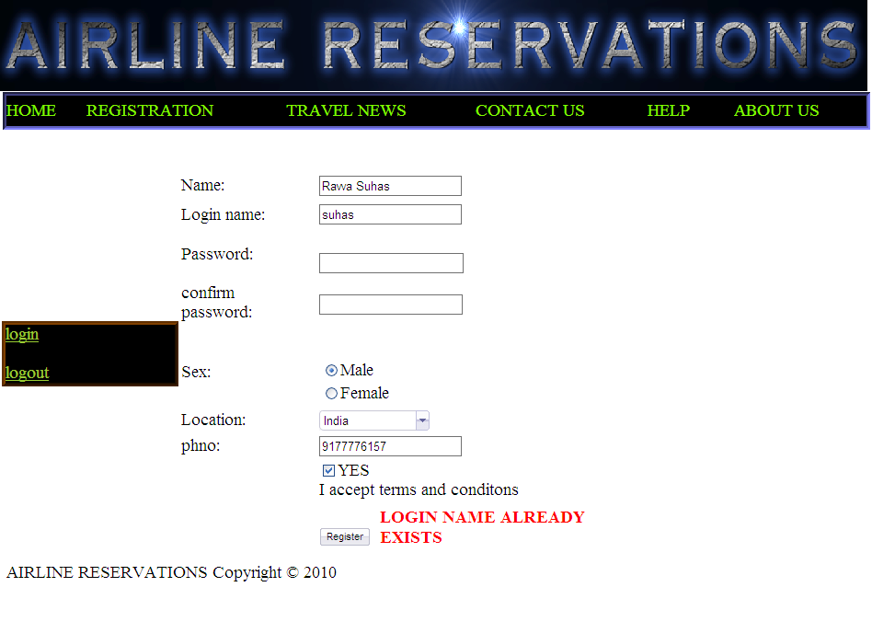

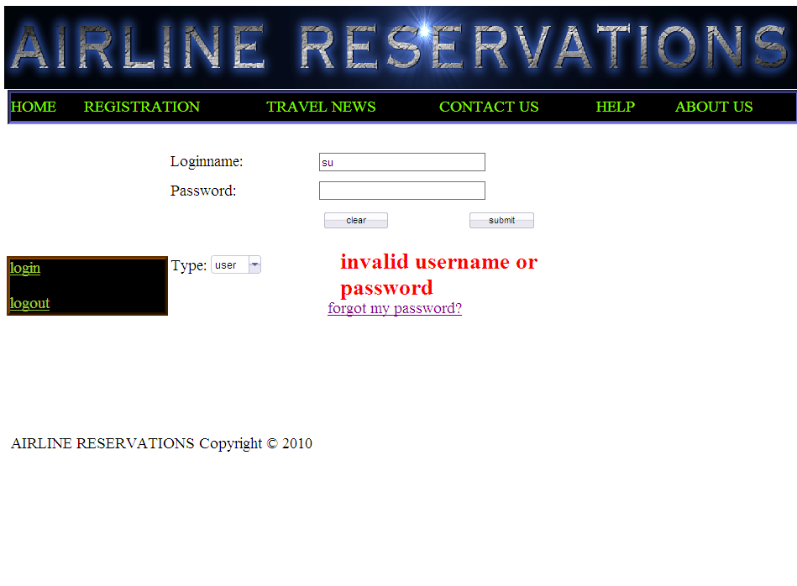
Description: The above is error message appears when user tries to give invalid username or password.

OUTPUT SCREENS

7. OUTPUT SCREENS

LOGIN FORM

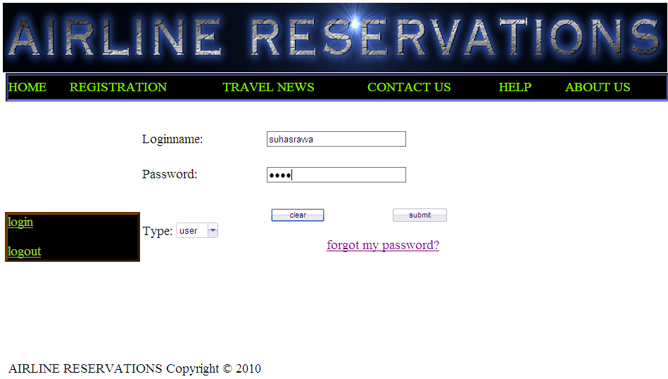

Description: This is login form for user and admin.

REGISTRATION FORM

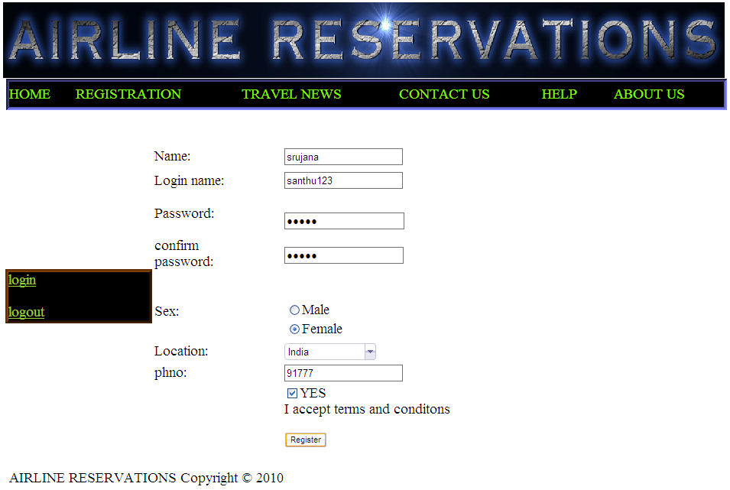

Description: This is registration form for registering with site, registered users will be provided with unique username and password.

FLIGHT SCHEDULES

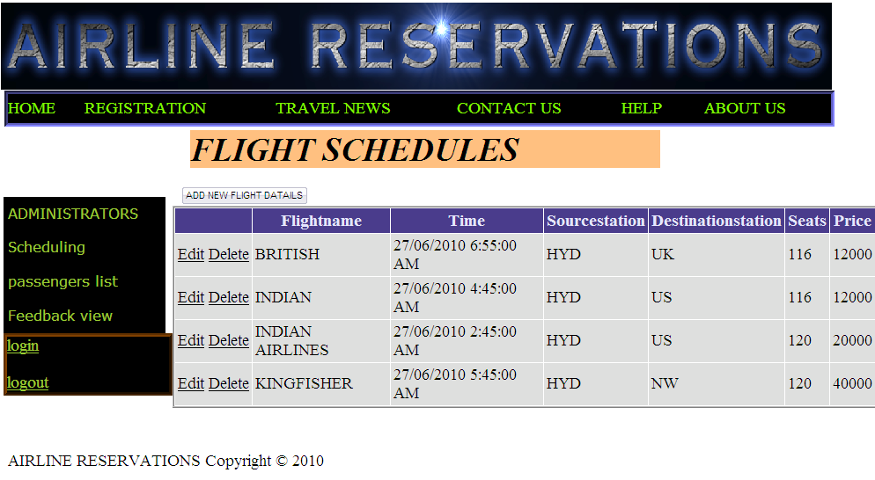

Description: Updating, deleting of flight can be done through this form by admin.

PASSENGERS LIST

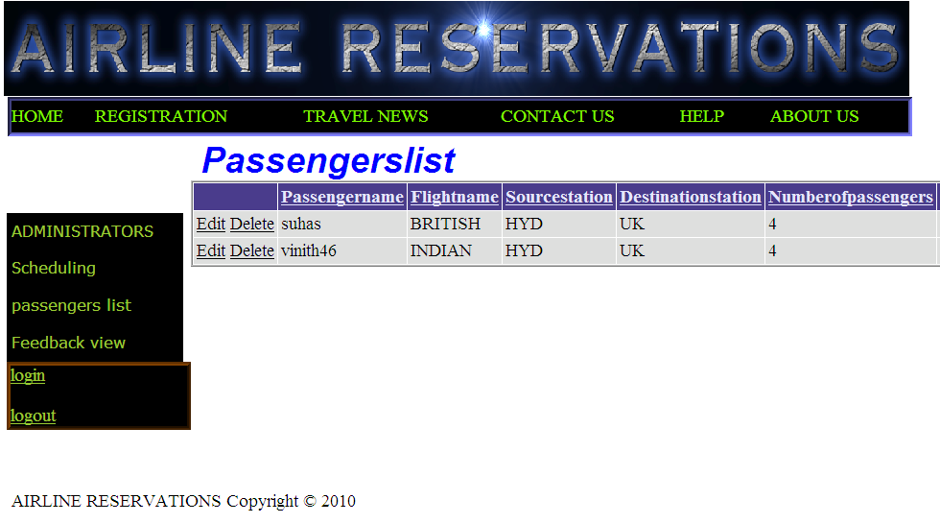

Description: This is list of passengers travelling through different flights can be managed by admin through this form.

FEEDBACK VIEW
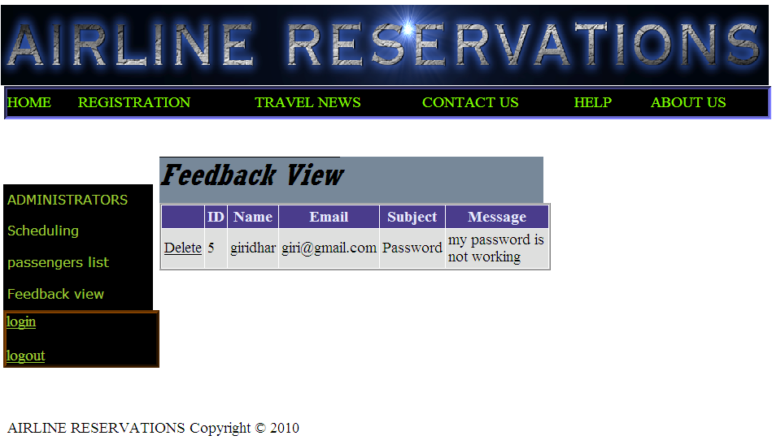

Description: This form shows feedback from passengers to admin.

TIMINGS OF FLIGHTS
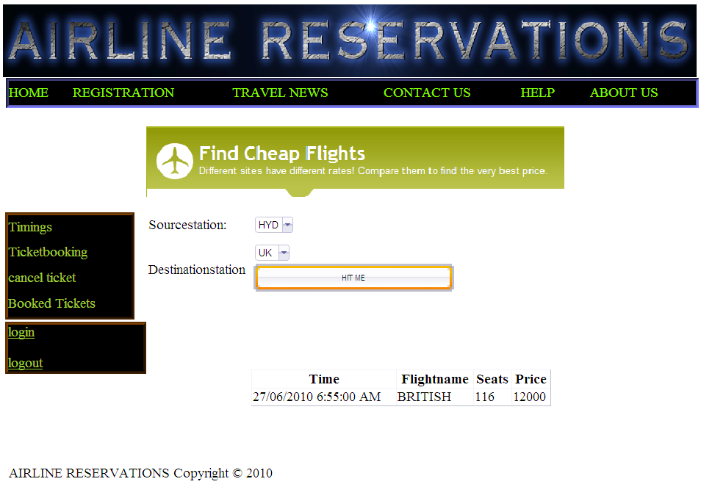

Description: This form gives timings of flights based on source and destination stations picked by user. Price and seats availability can also be viewed.

TICKET BOOKING

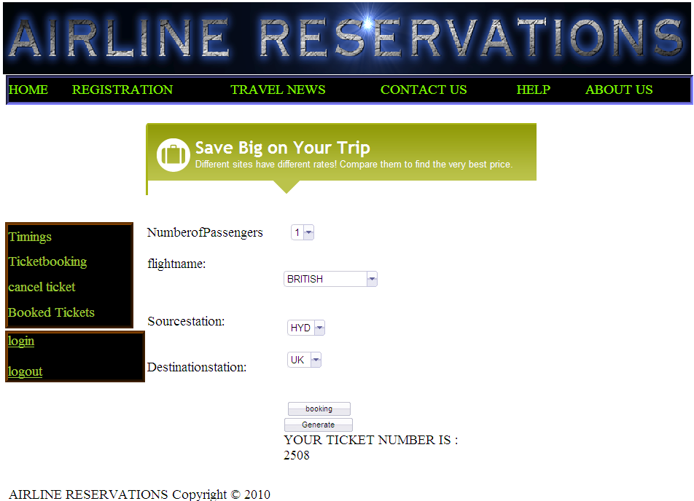

Description: This form is used to book the ticket and it generates the ticket id for user.

TICKET CANCELLATION

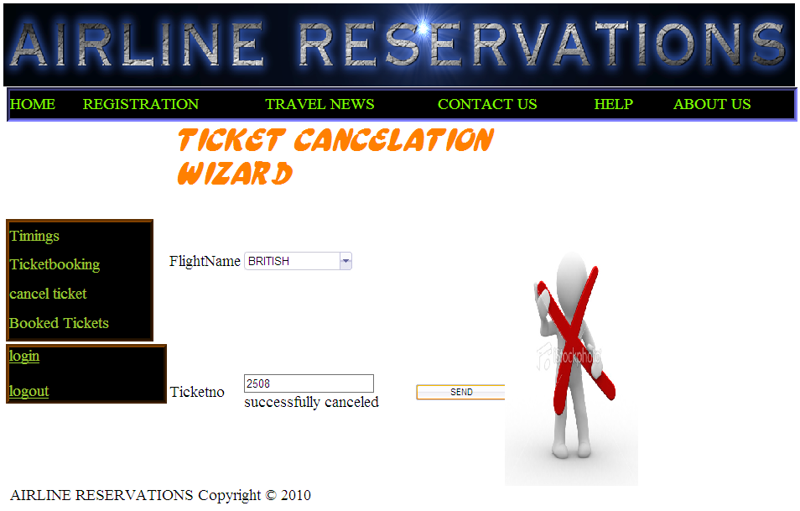

Description: This is a form through which passenger can cancel his ticket.

LIST OF TICKETS BOOKED BY USER

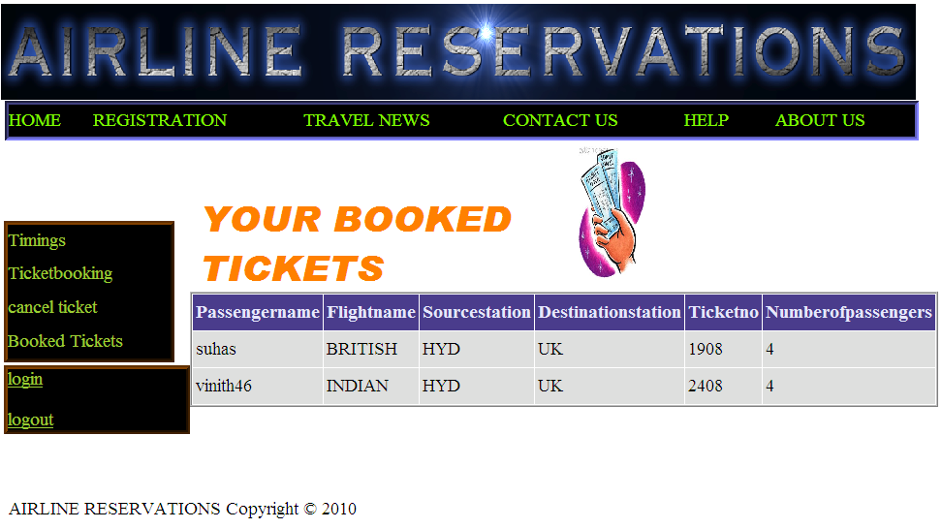

Description: This form displays list of tickets booked by passenger.

FEEDBACK FORM
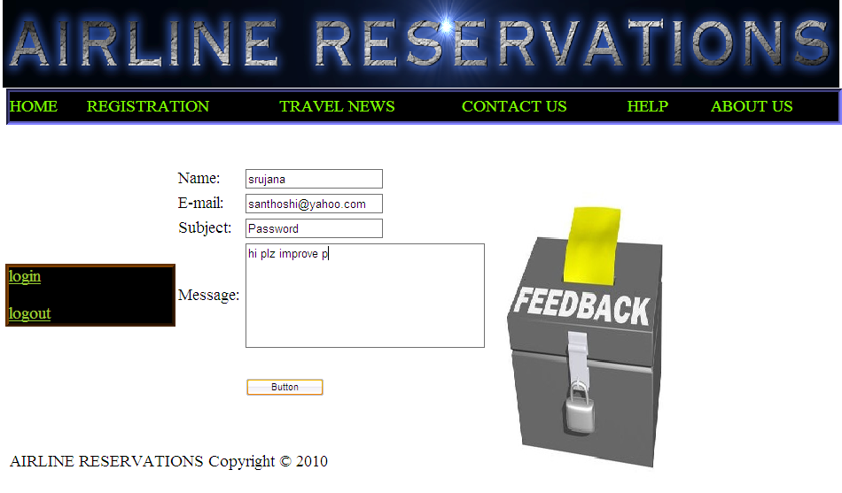
Description: This form is used to post the feedback from user to admin.

CONCLUSION

8.CONCLUSION
Getting accurate information about what visas or permits you need is an important part of preparing for a trip or stay abroad. To help you with this task we have provided information about embassies and consulates abroad, and we have also included companies that provide visa and passport services.

We offer documentation processing, application & filing services for those interested in applying for a visa.A strong research team ensures that cases are evaluated and processed as per the latest updated rules and regulations.

BIBILOGRAPHY

10. BIBILOGRAPHY

References:

SOFTWARE ENGINEERING - By Roger’s.Pressman
SQL FOR PROFESSIONALS - ByJain
ASP.NET with C# - By Wrox Publications
MSDN 2002 - By Microsoft

Websites:

- www.support.microsoft.com
- www.asp.net
- www.w3schools.com
- www.freetutes.com

